**An Eye on Modern Children’s Literature: The visual Element in The Children’s Poetry of Shel Silverstein**

**By**

Dr. Mahmoud Moawad Sokar, Al-Alsun Higher Institute

Abstract

*As literature aims to entertain the reader and to introduce morals, children’s literature has a deeper and more effective role as it enriches the mentality of children during their critical period. During children’s critical period, it is easy to teach them different skills and types of knowledge including aesthetics, languages, moralities, history, and religion. Here, it is worth mentioning that children’s literature is the gate through which children can deal with their early intellectual perception. Children’s literature includes a wide range of forms; however, poetry can be the most inspiring and motivating literary form due to its imaginative and aesthetic features. One of the modern modes of poetry that can be a rich educational material is visual poetry as it has the ability to introduce both visual and verbal elements. Consequently, the present paper aims at highlighting and analyzing the visual element of the Children’s poetry of Shel Silverstein as one of the prominent children’s poets who introduced children-visual poetry as a renovated and creative genre of children’s literature. In this regard, the present paper is an attempt to shed some light on the visual element in Shel Silverstein’s poetry for children through discussing some selected poems of the American writer, poet, cartoonist, songwriter and playwright. In addition, the study will discuss the main elements of visual-children’s poetry through highlighting the forms, techniques, visual elements, and themes used in this literary genre.*

**Key Words:**

Children’s literature, Children’s Poetry, Shel Silverstein, Children’s Visual Poetry

There is no specific definition of children’s literature; however, it can be broadly defined as the written works and illustrations intended to entertain or educate young people (Norton 12). Children’s literature includes classic children’s tales, picture books, easy-to-read stories written for children, fairy tales, lullabies, fables, folk songs, and other materials. Children’s literature is presented whether orally or visually in consideration of the nature of the receivers who may not have the ability to read, contemplate, or interpret the text. Here, the main definition and function of children’s literature is related to the receiver (the child) rather than the author as children’s literature gains its significance through its role in shaping the intellectual and critical abilities of the child.

Early children’s literature consisted of stories, songs, and oral poems that were used to educate and entertain children. In the eighteenth century, with the development of the concept of childhood, an individual genre of children’s literature began to emerge, with its divisions, expectations and forms (Horne 25). The oldest of these books were educational books for teaching children good behavior and the alphabet. These works were often illustrated with pictures of animals, plants, and anthropomorphic letters.

Amongst many forms of children’s literature, still poetry is the most influential educational material due to the usage of rhyme, rhythm, and interesting literary devices, such as metaphors and similes that help the child to reinforce the memorizing of the words and ideas of the poems. Memory is regarded one of the most influential approaches of learning that can use children’s poetry as a tool of learning. Based on the power of human mind, education necessitates a strong and long term-memory. This memory aims at making links and relations between the discourse and the visual element of text. Using memory for enhancing children’s skills requires many procedures and techniques such as spacing, pacing, apply, cognitive depth, organization, imagining, and substitution, and flexibility in order to help children to gain the required knowledge (Nemati 20). Consequently, this approach of learning can use poetry as a material of learning.

Poetry has a great ability to revive children’s memory and to make it ready to receive the required knowledge. However, some children regard the verbal element of the poem boring and rigid. That is why, adding the visual element to the poem can enrich the poem as an educational tool. Consequently, children-visual poetry may be the best and the most influential tool for children’s learning as it implies both visual and verbal elements.

One of the most remarkable poets who attribute the visual element to their poems is Sheldon Allan Silverstein. Sheldon Allan Silverstein (1930-1999) was an American writer, poet, cartoonist, musician, and playwright. His cartoons, songs, and children’s books were his most well-known works. In some of his works, he referred to himself as Uncle Shelby. His books have been translated into over 30 languages and sold over 20 million copies all over the world.

The children’s poetry of Silverstein has very specific characteristics. It is known to be ambiguous, humorous, and a little strange. One of the most special characteristics of his poetry is the use of black and white illustrations that make his poetry more interesting, simpler, and clearer for children. Here, Lisa Rogak describes Silverstein’s career as a children’s poet mentioning:

His boundless creativity brought him fame and fortune-neither of which changed his down-to-earth way of life-and his children's books sold millions of copies. But he was much more than "just" a children's writer. He collaborated with anyone who crossed his path, and found success in a wider range of genres than most artists could ever hope to master. ..He wrote experimental plays and collaborated on scripts with David Mamet. With a seemingly unending stream of fresh ideas, he worked compulsively and enthusiastically on a wide array of projects up until his death. (5)

Silverstein’s style is heavily influenced by the iconic authors of children’s literature, namely Edward Lear (1812- 1888), Alan Alexander Milne (1882-1956, and Dr. Seuss (1904-1991) who introduced interesting educational literary works for children. In this regard, Eric Kimmel (1946- ) describes Silverstein’s style mentioning: “His poems read like those a fourth grader would write in the back of his notebook when the teacher's eye was turned” (33). Moreover, his subtle use of illustrations is heavily influenced by their works. Their style of illustrations was influenced by cartoon and animated cartoon which was flourished in the 19th century as a form of para-literature.

Silverstein’s works were always put under heavy discussions and criticisms. Sometimes, they are considered as the best works to teach children through poetry; however, they were described as highly symbolic works that represent the author’s trend as black-comedy writer (Mamet VIII). In spite of these claims, the combination between the visual and verbal elements makes his works interesting, worth reading, and a rich material for academic study in children’s literature arena. In this regard, Lisa Breininger argues:

Many people have different options on what they think about the books Silverstein created. Some believe that these are educational readings while other people believe that these poems are harmful to children…Many people consider Where the Sidewalk Ends a classic piece. Some people think that his work makes children feel as though an adult understands them (4-6).

On discussing the visual element in poetry, especially in children’s poetry, it is necessary to define the visual element in poetry or what can be named “visual poetry.” The visual element in poetry represents an experimental poetic practice which is associated with an intermediate. As a multimodal literary genre, visual poetry can be defined as a combining employment of visual, verbal, and manual or digital human artistic activities that aims at constructing the meaning through introducing different hybrid representational techniques of writing or designing the poem (Huisman 41).

According to W.J.T. Mitchell, visual poetry represents a verbal-visual relation between image/text, or text-image in order to present synthetic relations between multi-human literary and artistic activities (2). However, the role of the visual element in visual poetry is totally different from the role of the element in children’s poetry. Visual poetry, as an experimental poetic practice, utilizes the visual element for conveying the author’s philosophy or ideology such as Fluxus, Dadaism, Surrealism, and others. On the other hand, the visual element in children’s poetry aims at facilitating the process of reading the verbal element either for the child or for the father∕teacher. In addition, the visual element in children’s poetry reinforces the child’s memory as it represents a supporting educational element. In this regard, Zhihui Fang highlights:

…picture books hold a prominent place in children's literature because of the juxtaposition of pictures and words. Thanks to the public's acute awareness of the importance of childhood in human development, to professional critical evaluation of children's literature, as well as to the advances in printing technology and art reproduction, children's literature has witnessed a dramatic increase in well-illustrated picture books (130).

Thusly, the visual element in children’s poetry makes the poems more interactive and more interesting as Bodmer argues that illustrations can “expand, explain, interpret, or decorate a written text” (72).

In addition, the relation between the reader and the author in adults’ poetry expands to be a triple-reading relationship in children’s poetry. In other words, reading a children’s poem not only depends on the content and the receiver (the child), but also it includes the guide who conveys the meaning to the child. The guide in this process may be one of the parents, the teacher, or the nursemaid

The visual element in the children’s poetry of Shel Silverstein is highly influenced by cartoons. His illustrations were simply designed in black and white to urge the children to draw similar illustrations. Silverstein’s illustrations, as a visual element, are unique and attractive. For Silverstein, these illustrations have certain objectives. They give faces to the characters, communicate the theme, visualize the plot, convey the characters’ expressions, raise the human emotions of the child, and finally, they reinforce the child’s memory.

One of the most iconic works of Silverstein is *The Giving Tree* (1964).The work was refused by the publisher as it, like most Silverstein’s works, bears many contradictive interpretations. The publisher claims that the work can be regarded as adult literature (Hines 126). However, the visual element within the work classifies it as a children’s literature. The poem which takes the form of a short story opens simply with a calm tone:

Once there was a tree….

and she loved a little boy.

And everyday the boy would come

and he would gather her leaves

and make them into crowns

and play king of the forest.

He would climb up her trunk

and swing from her branches

and eat apples….

(*The Giving Tree* 1-8)

The tree is verbally and visually portrayed as a woman who imparts happiness and joy to the boy. The tree symbolizes a “mother” as both of them are giver and generous creatures. The tree is not only a companion of the boy’s childhood, but it also helps him to make a boat during his adulthood: “I want a boat that will take me far away from here. Can you give me a boat?” …“Cut down my trunk and make a boat,” … and be happy” (20-21). The boy becomes an old man who asks the tree to give him a house: “I am too busy to climb trees,” said the boy… “I want a house to keep me warm” (47-48). By the end of the story, the tree does not have anything to give. It is weak and old. It has neither apple nor wood to give. Unlike children’s poems and tales, the story here is sad and gloomy with the implications of death and *Carpe diem*.

The work looks like a PowerPoint presentation which is introduced through pages. Each page represents a slow-motion of a shot in the story. The little differences between each page and the succeeding one make the whole book seems like a cartoon movie. The black and white simple illustrations used by Silverstein may be attractive to the child more than the confusing colored ones. Here, it is worth mentioning that the use of black and white illustrations becomes one of the main features of Silverstein’s works.

The visual element within the poem has a great significance as it visualizes the main characters of the poem. In addition, it makes the poem more understandable and attractive. It also facilitates the process of reading for the reader either a father or a teacher. Moreover, the visual element of the poem removes the ambiguity concerning dealing with it as an adult poem:

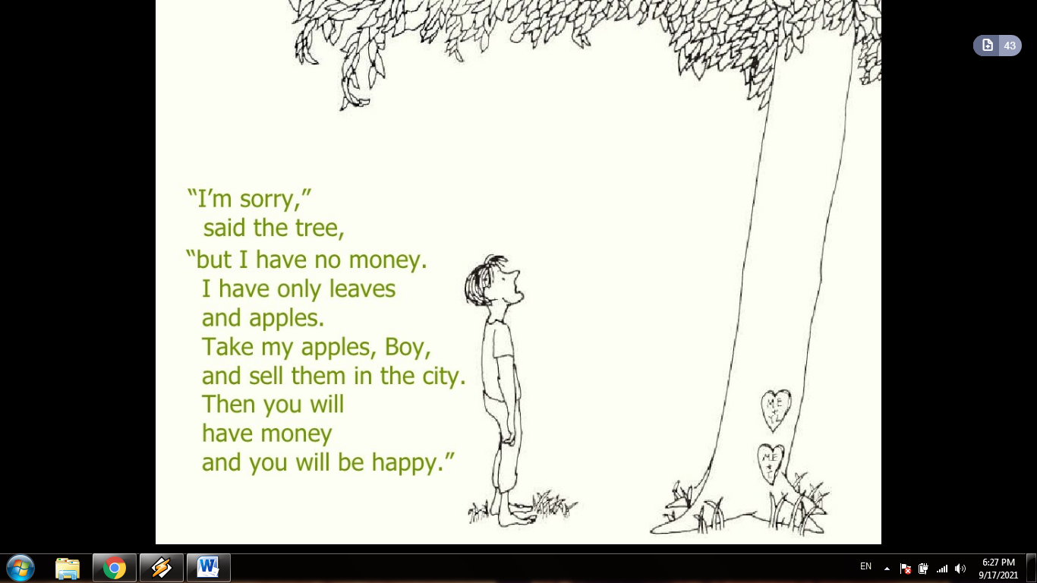

(*The Giving Tree* 80-89)

In spite being classified as a children’s poem, the poem bears many interpretation. Silverstein himself mentions in *Something about the Author* that the poem is a representation of “a relationship between two people: one gives and the other takes” (Commire and Olendorf 90). Barbara A. Schram describes the work as “dangerous…glorification of female selflessness and male selfishness” (qtd. in Hines 120). The poem also has a religious interpretation as it deals with the theme of giving from a Christian perspective. In addition, the poem can be read in terms of feminism as it symbolizes mother’s sacrifice versus the selfishness of males. In addition, the poem has ecological interpretations.

Some critics argue that the tree symbolizes [Mother Nature](https://en.wikipedia.org/wiki/Mother_Nature), whereas the boy symbolizes humanity. Consequently, this book of poems is regarded one of the best sources for teaching [environmental ethics](https://en.wikipedia.org/wiki/Environmental_ethics) (Goodnough 11).  Some educational resources for children deal with this work as “allegory about the responsibilities a human being has for living organisms in the environment” (Fredericks 28). In this regard, Lisa Rowe Fraustino mentions that “some curricula use the book as a what-not-to-do role model” (Fraustino 290).

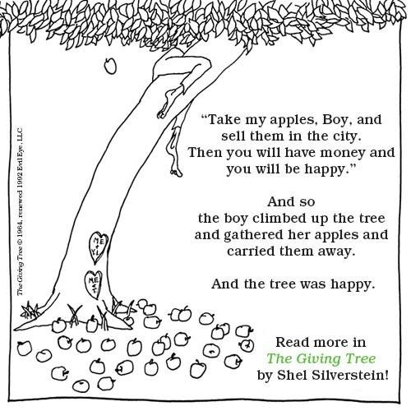

(*The Giving Tree* 31-39)

While “The Giving Tree” introduces a talented visual representation, “Backward Bill” presents both visual and verbal unique representation. The subtle use of sounds, besides the interesting visual element within the poem, turns the poem to be a performance poem rather than a mere visual poem. Silverstein utilizes precise music devices, namely the heavy use of alliteration. The rhyme scheme: aabc ddee bc-- ffaa gghh makes the poem easy and smooth to read. In addition, the use of Trochaic tetrameter makes the musical effect in the poem unique and different:

Backward Bill, Backward Bill,

He lives way up on Backward Hill,

Which is really a hole in the sandy ground

(But that's a hill turned upside down).

Backward Bill's got a backward shack

With a big front porch that's built out back.

You walk through the window and look out the door

And the cellar is up on the very top floor.

Backward Bill he rides like the wind

Don't know where he's going but sees where he's been.

His spurs they go "neigh" and his horse it goes "clang,"

And his six-gun goes "gnab," it never goes "bang."

Backward Bill's got a backward pup,

They eat their supper when the sun comes up,

And he's got a wife named Backward Lil,

"She's my own true hate," says Backward Bill…

(*Backward Bill* 1-16)

The poem tells the story of the strange Backward Bill who lives in Backward Hill. His house is strange like him. The way he rides his horse is also strange. No one can know his destination; however, people may know it where he has been after his return. Not only Bill is “backward,” but also his wife and even his dog are “backward.” Bill mentions that his wife is his own “true hate.” He wears his clothes in reverse “hat on his toes” and “underwear over his clothes” (18-19). Bill’s work is also strange as he “he pays his boss” (20). The last line of the poem reveals a new shocking fact about Bill. He carries his horse.

The story of this strange man bears two interpretations. The first represents the story of a foolish man who acts in a strange way to make funny stories. This interpretation may not be logic; however, it is supported by the illustrations of the poem. This interpretation highlights that the poem is influenced by the story of Juha, the Arab wise fool. Juha, like Bell, is known for his strange behaviors that make funny and interesting stories (Jayyusi 5):

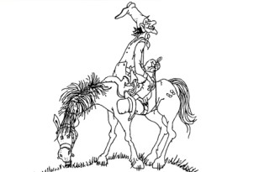

(*Backward Bill* 1)

The second interpretation of the poem does not consider the poem as a children’s poem. In other words, Silverstein uses exaggerative ideas to convey the opposite meaning of the text. Here, the reader can consider Bill as a wise man, who is clever, energetic, tidy, and loving for his wife. This interpretation may be supported by the use of spoonerisms as word-play technique that is utilized in the poem. [Spoonerisms](https://en.wikipedia.org/wiki/Spoonerism) confirm the ideas-play claimed in this interpretation. This interpretation raises the controversial doubts about Silverstein as a children’s poet. In this interpretation, the poem is highly philosophical and absurd. Consequently, it does not fit a child; however, Silverstein’s illustrations may be considered a tricky technique to classify his poems as children’s poems.

*Runny Babbit: A Billy Sook* is a poetic work which depends on “[spoonerisms](https://en.wikipedia.org/wiki/Spoonerism)” and rhyming sounds (Rogak 190). Spoonerisms are verbal word-game in which the speaker accidentally exchanges of the first letter of two words (MacKay 332). Spoonerisms leave a comic and funny expression in the poem. In addition, they are similar to the tongue twister which is used to teach children how to pronounce words. This spoken-word game makes the text, funny, interesting, and easy to learn.

The poem is a story of a child, Runny who has loving parents and a lot of friends. The educational part of the poem is represented by Dummy and Mad who always advise him to “Shake a tower,” “Dash the wishes,” “Trush your beeth,” “Rean up your cloom,” and other chores. The work is a funny book of poems that mainly aims at learning through fun. The style the poem depends on “spoonerism” which is a well-known classical technique of writing children’s songs. That is why, this work is regarded one of the best materials for learning through fun.

Spoonerisms depend on turning the first letter of each of a two-word, for example, “Bunny Rabbit” turns to “runny babbit,” “hurple pat,” and “ceed the fat.” This technique increases the children’s ability to think and understand the real meaning of the poem through rearranging the word again to perceive it. Here, it worth mentioning that this technique enhances students’ understanding of a “morpheme” as the smallest unit in a language. The poem is also influenced by the Yankee Doodle and traditional ditties.

The visual element of the poem, like most of Silverstone’s works, reinforces the meaning of the verbal element. The illustrations depict “Runny’s Hew Nobby” goes where a “swat and heater” are knitted; however, at the end. “one slong leeve” appears on the printed page, whereas poor Runny in puzzled when he look at his knitting needles:

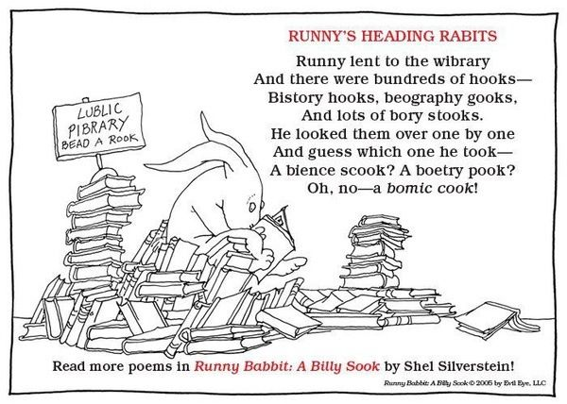

(*Runny Babbit: A Billy Sook* 1*)*

The work is not only a “performance” poem that teaches children moralities and the language, but also it is a material for improving children’s speaking skill through the technique of tongue twister that is regarded a very effective tool for overcoming speaking problems for children (Wilshire 60). Hence, Sally Lodge elaborates:

In "Runny's Heading Rabits," for example, readers will discover that this lapin likes his reading material on the light side: "Runny lent to the wibrary/ And there were bundreds of hooks—/ Bistory hooks, beography gooks,/ And lots of bory stooks./ He looked them over one by one/ And guess which one he took—/ A bience scook? A boetry pook?/ Oh, no—a bomic cook!" Obviously anticipating that Silverstein's legion of fans will hop to buy this tongue-twisting tale, which has a laydown date of March 15, HarperCollins is rolling out with a 500,000-copy first printing. (Lodge 12).

The work is performance-educational poem that combines both visual and verbal elements. Like most of Silverstein’s poems, the poem visualizes the character in order to convey the moralities of the work. The visual element in the poem is suitable for both children and adults. In this way, the reader who may be one of the parents or a teacher can simply convey the meaning as he enjoys the work as the child does. Here, Joan Robins clarifies:

He never discarded anything definitively. He liked to have as many readers of all ages as possible respond to his work and to indicate to him which of a set of poems and drawings were their favorites. This feedback seemed to feed his creativity. In the end, every revision he made was a new creation, starting with the word, adding or subtracting from the line drawing. His revisions continued into the blues, a challenge to the patience of printers and production people—and, of course, editors. You had to go with his flow, up to the final printings. And it always proved worth it. (qtd. in McDowell 12)

Like most of Silverstein’s poems, “Early Bird” bears two interpretations. The first links the poem to children’s poetry, whereas the second is highly philosophical. The second interpretation does not consider the poem as children’s poem and relates it to adults’ poetry. Again, the visual element of poem saves Silverstein as it elaborates that the poem belongs to children’s literature:

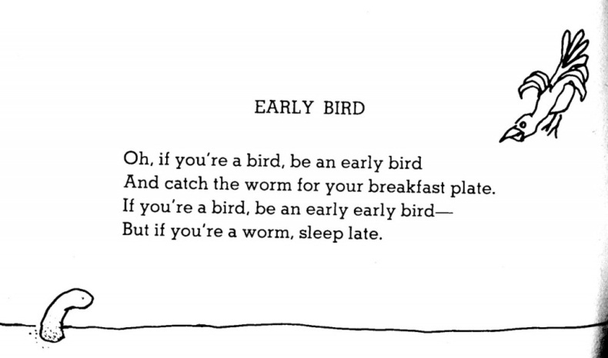

(“Early Bird” 4)

On the surface level, the poem is a simple educational work that advises children to get up early in order to be like “early bird” and not to be “worm.” The early bird is strong, fast, and determined, whereas the late worm is weak and lazy. The poem consists of four lines that follow ABAB rhyming scheme. The rhyme scheme used in the poem increases the musical effects and makes the poem appropriate for children.

On the deeper level, the poem is a visual-philosophical poem that criticizes Capitalism and wars. Anti-war is a very familiar theme in visual poetry. Consequently, the poem may be an anti-war poem. That is to say, the early bird may symbolize the great powers in the world, while the worm is the vulnerable states that are invaded and occupied by the great powers. This interpretation makes the poem political and not appropriate for children at all. Here, it is worth mentioning that this interpretation may be supported by Silverstein’s adoptation of black comedy as one of his interests (Mosher 6).

Nevertheless, the visual element of the poem supports the first interpretation. On the top-right, the reader can see the early bird ready for catching his prey. While, the late worm is frozen waiting for its destiny as a victim. The movement of the early bird which is moving in fierce and angry way raises the doubts about the poems’ appropriateness for children.

**Conclusion:**

To sum up, Shel Silverstein is a talented visual poet who introduced creative children-visual poems with deep and interesting ideas that are appropriate for both children and adults. However, the visual element within Silverstein’s poems may be a trick for attributing his poem to children poetry’s arena. Many of his poems bear two interpretations: the first is associated with children, whereas the second is related to adults. The double meaning utilized by Silverstein may be a tricky strategy for widening his readership base through making poems that attract both children and adults. Silverstein is ahead of his time as he is regarded one of the early poets who introduced a “performance poem” that combines both illustrations and musical effects. Silverstein’s poems are not mere poems for fun; however, they are educational poems that raise children’s critical and mental abilities. As a final point, the study suggests further studies to cover some related topics, such as Shel Silverstein’s performance poetry and his unique use of musical devices.

**References:**

Bodmer, George R. "Approaching the illustrated text." *Teaching children's literature: Issues, pedagogy, resources* (1992): 72-79.

Commire, Anne, and Donna Olendorf. *Something about the Author: Facts and Pictures About Authors And Illustrators of Books for Young People*. Gale/Cengage Learning, 2004.

Fang, Zhihui. "Illustrations, text, and the child reader: what are pictures in children's storybooks for?." *Reading Horizons: A Journal of Literacy and Language Arts* 37.2 (1996): 3.

Fredericks, Anthony "26. The Giving Tree". *The Librarian's Complete Guide to Involving Parents Through Children's Literature Grades K-6. Englewood, CO*: Libraries Unlimited. 1997.

Goodnough, Abby. "The Examined Life, Age 8". *The New York Times*. 2013.web. 2021.

Hines, Maude. "Drawing the Line: The Giving Tree's" Adult" Lessons." *Children's Literature* 47.1 (2019): 120-148.

Horne, Jackie C. *History and the Construction of the Child in Early British Children's Literature*. Routledge, 2016.‏

Jayyusi, Salma Khadra, ed. *Tales of Juha: Classic Arab Folk Humor.* Interlink Publishing Group Incorporated, 2007.

Kimmel, Eric A. "Shel Silverstein: Overview." *Twentieth-Century Children's Writers* (1995).

Lodge, Sally. “A Look Behind Shel Silverstein's Bew Nook” *Publishers Weekly*. Volume 252 Issue 9 02/28/2005. web. 2021.

MacKay, Donald G. "Spoonerisms: The structure of errors in the serial order of speech." *Neuropsychologia* 8.3 (1970): 323-350.

Magid, Annette M., ed. *You are what you eat: literary probes into the palate*. Cambridge Scholars Publishing, 2009.

Mamet, David. *Mamet Plays: 3: Glengarry Glen Ross; Prairie du Chien; The Shawl; Speed-the-Plow*. Bloomsbury Publishing, 2016.‏

McDowell, Edwin. “Behind the Best Sellers; SHEL SILVERSTEIN.” The New York Times. 1981. web. 2021. *nytimes.com.*

Mitchell, W. J. ―Image X Text. eds. Ofra Amihay and Lauren Walsh. *The Future of Text and Image*. Newcastle: Cambridge Scholars Publishing, 2012. Print.

Mosher, Derek S. *The Creepy Little TV Guy*. Indiana University, 2002.

Nemati, Azadeh. "Memory vocabulary learning strategies and long-term retention." International journal of vocational and technical education 1.2 (2009): 014-024.

Norton, Donna E. "Through the eyes of a child: An introduction to children's literature." (1991).‏

Place, Vanessa, and Robert Fitterman. *Notes on Conceptualisms*. New York: Ugly Duckling Presse, 2009. Print.

Rogak, Lisa. *A boy named Shel: The life and times of Shel Silverstein*. Farrar, Straus, and Giroux, 2007.‏

Silverstein, Shel. *A light in the attic*. New York, NY: HarperCollins, 1981.‏

Silverstein, Shel, Natalie Freeman, and Amos Paul Kennedy. *The giving tree*. New York: HarperCollins, 1964.‏

Wilshire, Carolyn E. "The “tongue twister” paradigm as a technique for studying phonological encoding." *Language and Speech* 42.1 (1999): 57-82.